### **Case Study: Customer Segmentation Analysis of Online Retail Data**

**Project Overview**

This project aimed to segment customers based on their spending and purchasing frequency to enable the business to personalize marketing strategies. By grouping similar customers, the company can develop tailored marketing initiatives to maximize engagement and increase sales.

**Introduction**

Understanding consumer behavior is essential for adjusting marketing tactics and making the most use of available resources in the cutthroat retail sector of today. By grouping clients according to frequency, spending habits, and purchase patterns, customer segmentation enables more individualized interactions and raises customer satisfaction. Data from a UK-based online retailer will be used in this case study to segment customers, spot buying patterns, and offer useful insights.

**Research Objective**

The objective of this analysis is to use customer segmentation to identify unique groups of customers based on purchasing behavior. By understanding these segments, the company can better target its marketing efforts, potentially increasing customer engagement and revenue.

**Research Questions**

1. What distinct customer segments can be identified from purchasing data?
2. How does each segment differ in terms of spending and purchasing frequency?
3. What strategies can be recommended for each customer segment?

**Methodology**

1. **Data Preparation**:
   * Clean the data by handling missing values and removing irrelevant transactions (e.g., returns).
   * Create key customer metrics such as total spending, purchase frequency, and total quantity purchased.
2. **Feature Engineering and Scaling**:
   * Generate features to represent customer behavior and scale these features for clustering.
3. **Clustering Analysis**:
   * **K-Means Clustering** was applied to group customers based on Total Spend and Frequency.
   * **The Elbow Method** was used to determine the optimal number of clusters, with an elbow curve indicating an optimal value at **K=4**.
   * The dataset was divided into 4 clusters, representing distinct customer behaviors.
4. **Visualization**:
   * Plot customer segments based on spending and frequency to understand segment characteristics and visualize clusters.

**Data Overview**

The dataset contains transactions from December 2010 to December 2011 for a UK-based online retailer. Key columns include:

* InvoiceNo: Unique number for each transaction.
* StockCode: Product code for each item.
* Quantity: Number of items purchased.
* InvoiceDate: Date and time of the transaction.
* UnitPrice: Price per unit of the product.
* CustomerID: Unique ID for each customer.
* Country: Country of the customer.

**Analysis using Python**

**Google Colab:** [Customer Segmentation Analysis of Online Retail Data](https://colab.research.google.com/drive/1VPf3JQ9P8mAlFOZoFM_jOQYCkj1Au3Cj?usp=sharing)

1. **Exploratory Data Analysis**

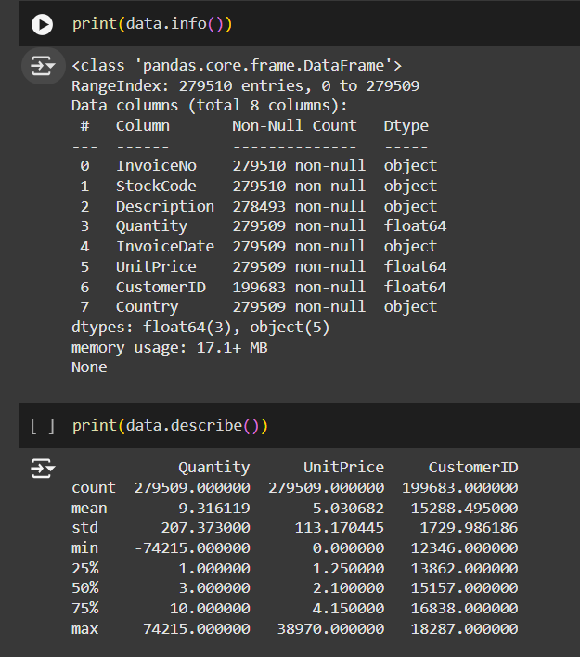

1. **Feature Selection**

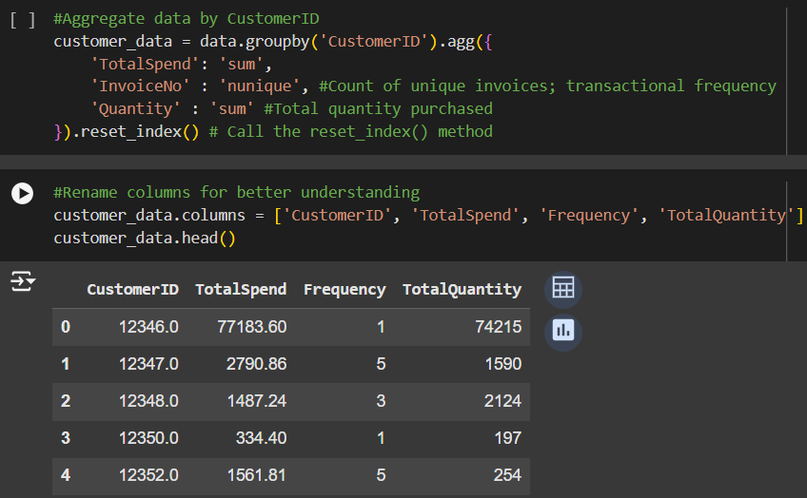

1. **Elbow Curve Analysis**

The Elbow Curve (Figure 1) shows how inertia changes as the number of clusters increases. The optimal point (K=4) was chosen where the curve begins to flatten, indicating that four clusters provide an adequate balance of compactness and distinct group formation.

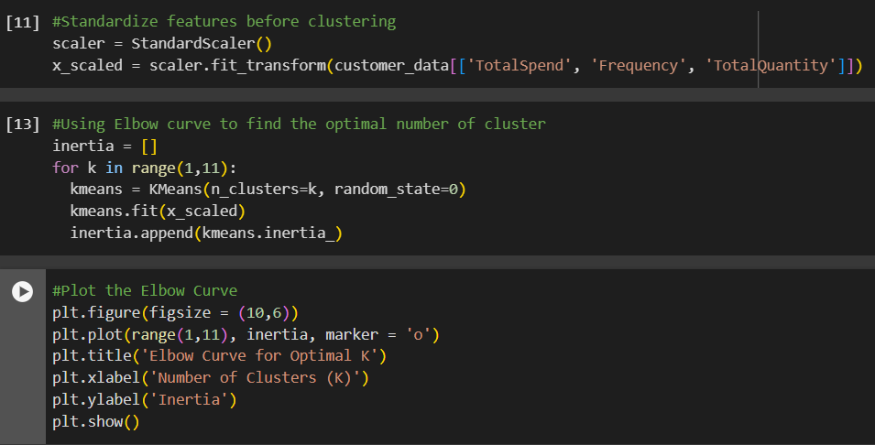

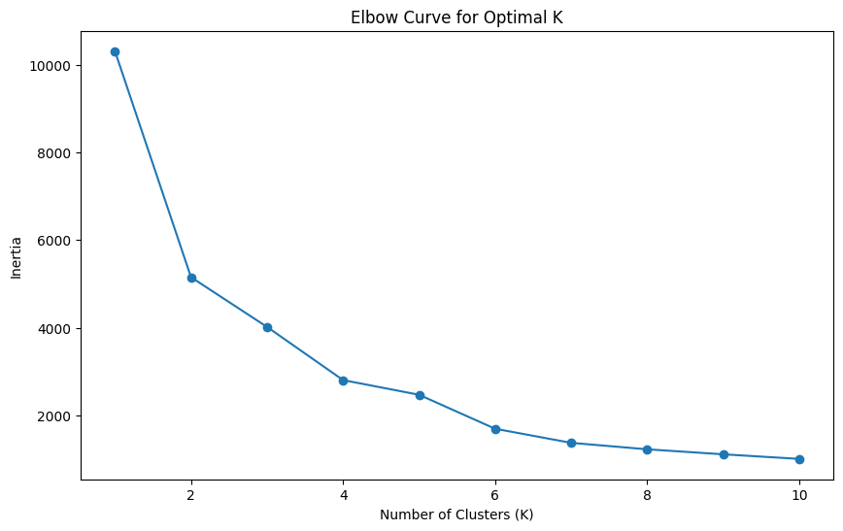

Figure-1

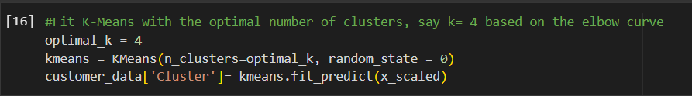

**Code Explanation:**

1. **Elbow Method:** The elbow method was used to determine the optimal number of clusters by plotting the inertia (sum of squared distances between points and their cluster center) for various K values.
2. **Fitting K-Means:** Once K=4 was chosen, the K-Means model was trained to place each client in one of four clusters.
3. **Cluster Visualization and Insights**

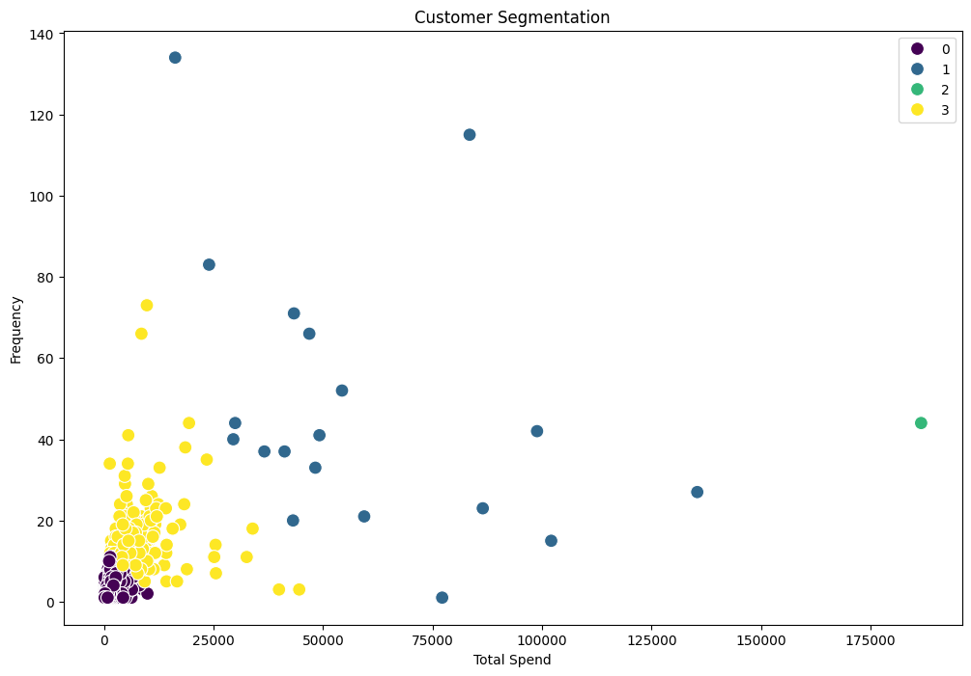

Figure - 2

The scatter plot (Figure 2) below depicts customer segmentation according to Total Spend (x-axis) and Frequency (y-axis). Every hue symbolizes a separate cluster.

1. Cluster 0 (Low Spenders, Low Frequency):

* Characteristics include low expenditure and purchasing frequency.
* Interpretation: Casual shoppers with limited brand commitment.
* Marketing Strategy: Implement loyalty programs to encourage regular purchasing.

1. Cluster 1 (Medium to High Spenders, High Frequency):

* Characteristics: Moderate to high spending, with frequent purchases.
* Interpretation: This group is likely to include loyal customers.
* Marketing Strategy: To keep customers loyal, offer special incentives or rewards.

1. Cluster 2 (High Spenders, Low to Moderate Frequency):

* Characteristics: Combines high spending with low to moderate purchase frequency.
* Interpretation: Infrequent yet high-value customers.
* Marketing Strategy: To keep high-value clients, offer personalized services or VIP bonuses.

1. Cluster 3 (Moderate Spenders, Moderate Frequency):

* Characteristics include moderate spending and purchasing frequency.
* Interpretation: This is a balanced group, with neither exceptionally high nor low spending.
* Marketing Strategy: Promote products that provide good value for money to stimulate more purchasing.

**Key Findings**

**Four separate Customer Segments:** The clustering revealed four separate segments with different spending and frequency characteristics.

**Segment characteristics**:

* Cluster 0 represents low-value clients who make infrequent transactions.
* Cluster 1 includes loyal clients who shop frequently.
* Cluster 2: High-value, sporadic consumers.
* Cluster 3 has moderate spenders with a balanced shopping frequency.

**Marketing insights**:

* Tailoring techniques can boost engagement for specific segments.
* Personalized offerings could help retain high-value clients in Cluster 2.

**Recommendations**

Based on our findings, here are focused recommendations for each consumer cluster to help Walmart optimize its marketing approach, increase customer loyalty, and drive sales growth:

* Cluster 0: Implement Loyalty Rewards to Increase Purchase Frequency

Cluster 0 is made up of customers who make fewer purchases and are unlikely to have strong brand loyalty. To increase involvement among this demographic, Walmart may develop a loyalty rewards program that offers points or discounts for recurring purchases. Walmart may encourage these customers to make Walmart their preferred store by offering incentives for regular purchases. Personalized offers based on purchase history, as well as notifications about award expiration, can help to increase the program's success.

* Cluster 1: Provide exclusive deals to keep loyal customers engaged.

Cluster 1 indicates devoted Walmart customers who shop frequently. To maintain and engage this demographic, Walmart should prioritize exclusive discounts and early access to promotions. For example, providing unique discounts, early access to new products, or members-only events could make these customers feel appreciated. Walmart may also implement a tiered loyalty program in which highly active customers receive premium advantages such as tailored suggestions and special promotions to sustain their long-term devotion.

* Cluster 2: Offer VIP bonuses and specialized services to high-value, infrequent shoppers.

Cluster 2 features high-value clients who shop infrequently. These people tend to spend a lot of money on their purchases, although they may not visit Walmart as frequently. To promote customer engagement, Walmart may offer VIP perks or unique services tailored to their demands. For example, providing home delivery services, expedited checkout, or a specialized shopping assistant for significant purchases might make their shopping experience more convenient and exclusive. Regular reminders of exclusive privileges offered only to high-value consumers can motivate them to shop at Walmart more frequently.

* Cluster 3: Focus on Value-for-Money Products to Increase Spending in This Balanced Group

Cluster 3 consists of people that have a balanced spending behavior and frequently choose Walmart due to its affordability. To encourage more purchasing among this demographic, Walmart should showcase its value-for-money products through cost reductions and package promotions. Marketing initiatives that highlight Walmart's high-quality products at competitive rates, as well as bundled offers or discounts on regularly purchased items, can encourage this demographic to spend more money. Walmart might also try offering customized specials on essential goods or seasonal items that are relevant to their purchase behavior.

**Conclusion**

This customer segmentation research offers a structured technique for categorizing and understanding various categories of customers based on their spending habits and buy frequency. By identifying distinct consumer segments, the organization can execute focused marketing techniques that are tailored to each group's behavior, potentially increasing customer retention and revenue.